PreLab CNN

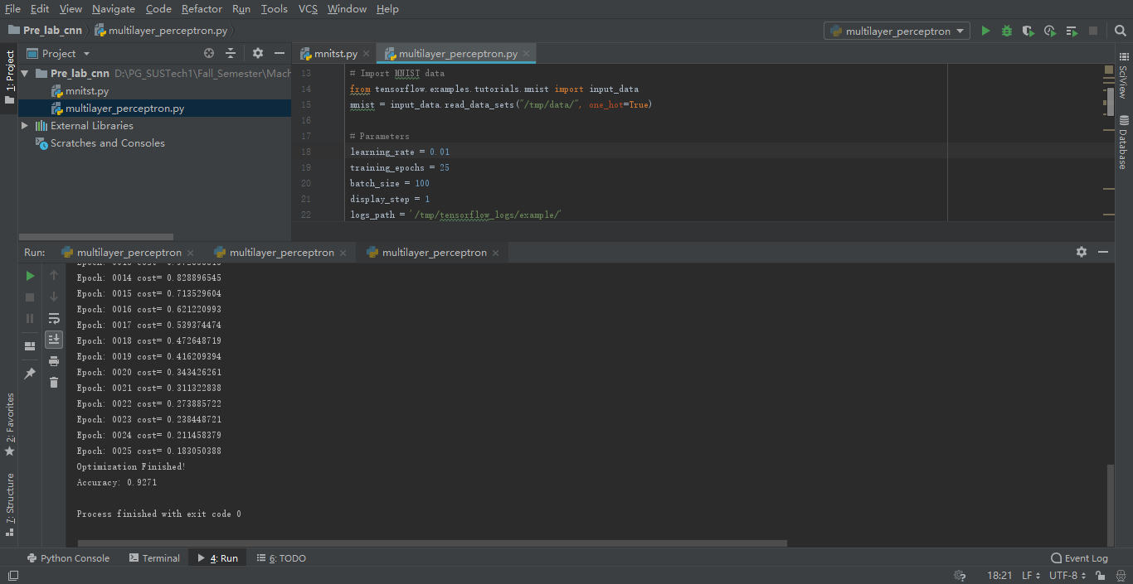

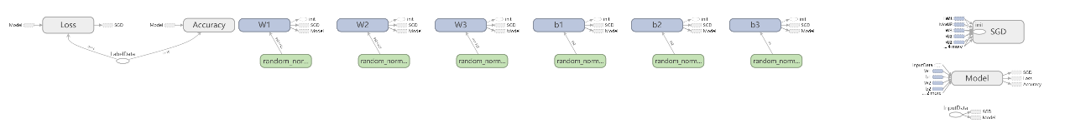

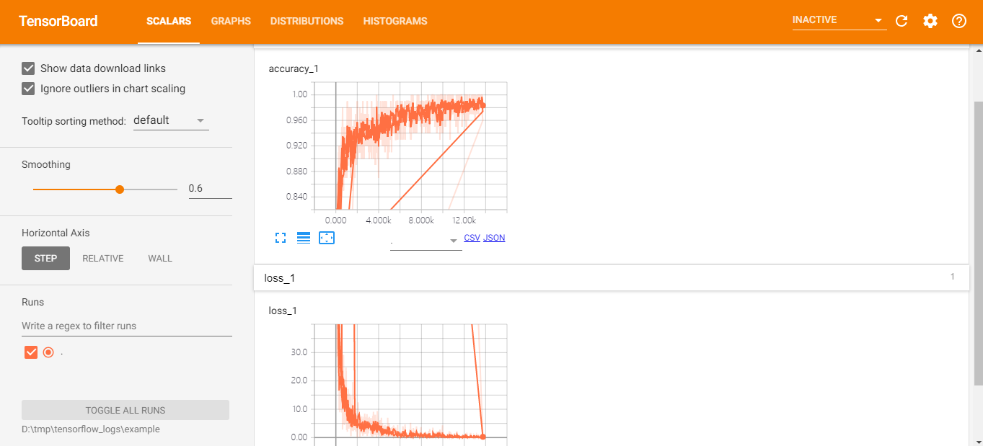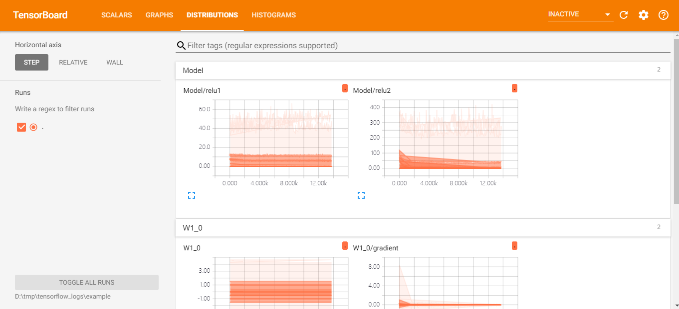

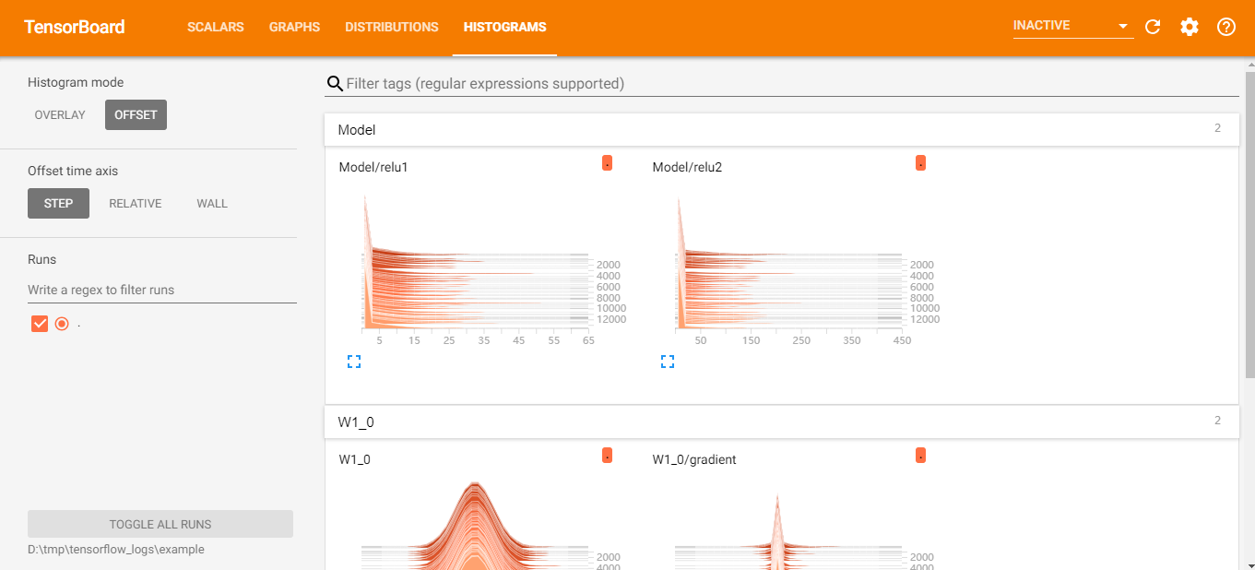

Loss Function:

It’s a method of evaluating how well your algorithm models your dataset.

SGD:

One method of Loss Function.

Activation function:

Achieve nonlinearity between the input and output.